**1. Business scenario**

As the most environmentally-friendly of the fossil fuels, natural gas provides 29 percent of our total energy supply[1] and generates approximately 33 percent of our electricity.[2]

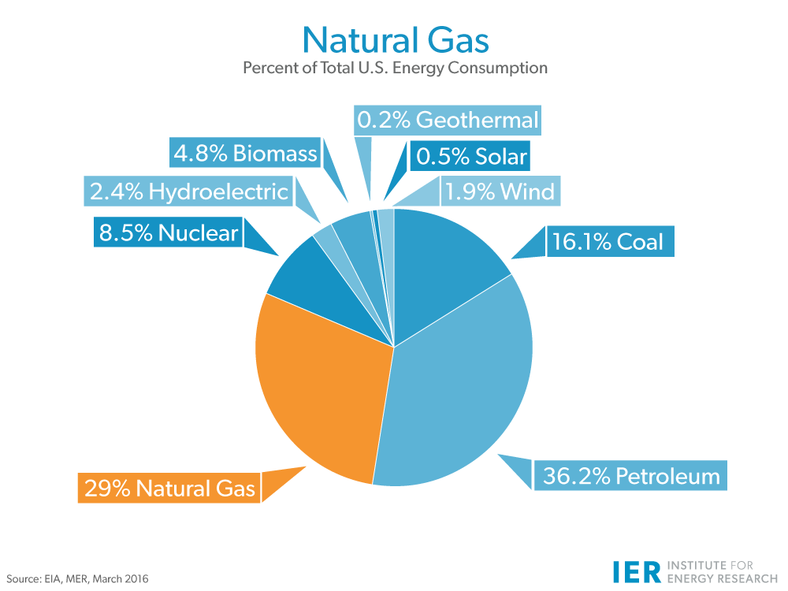



In 2008, natural gas only occupied 24 percent of the total energy supply. The Energy Information Administration (EIA), in its Annual Energy Outlook 2016, projects that natural gas demand could be from 120 trillion cubic feet (Tcf) in 2012 to 203 Tcf in 2040. The demand of Natural gas increased so quickly and we really want to know what factors affect the trendy of its consumption. Is it true that natural gas consumption declining as prices rise? We will build a model to predict natural gas demand and answer this question.

**2. Business objectives**

United States natural gas consumption by end use is influenced by many factors such as pricing, weather, population growth, and infrastructure development. We will choose two main factors, price and weather. And, we wanted to choose Illinois State as the studying region, highlight the impact of natural gas prices and weather on natural gas consumption. The built regression models driven by weather trends and pricing data can be used as a simple predictive tool in forecasting natural gas demand.

**3. Identify and Select Data**

* The data to build the model will be information about the natural gas which includes the price and consumption in different categories.
* The data to build the model will be information about the weather in the target region.
* We will go through the different month and tried to find the relations between the price of natural gas, weather and the consumption.

**4. Data Sets**

* Natural gas monthly consumption by end use in Illinois
* Sources: Energy Information Administration: <http://www.eia.gov/dnav/ng/ng_cons_sum_dcu_sil_m.htm>

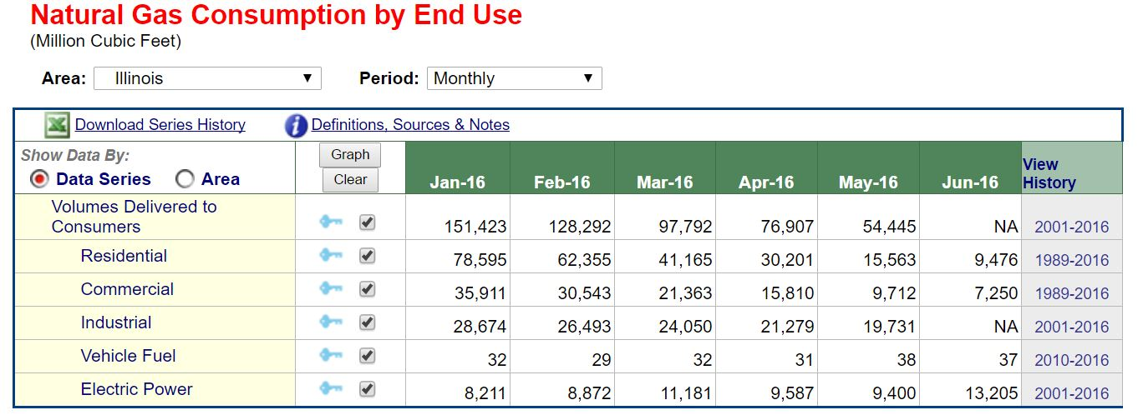

* Natural gas monthly price in Illinois
* Source: Energy Information Administration: <http://www.eia.gov/dnav/ng/ng_pri_sum_dcu_sil_m.htm>

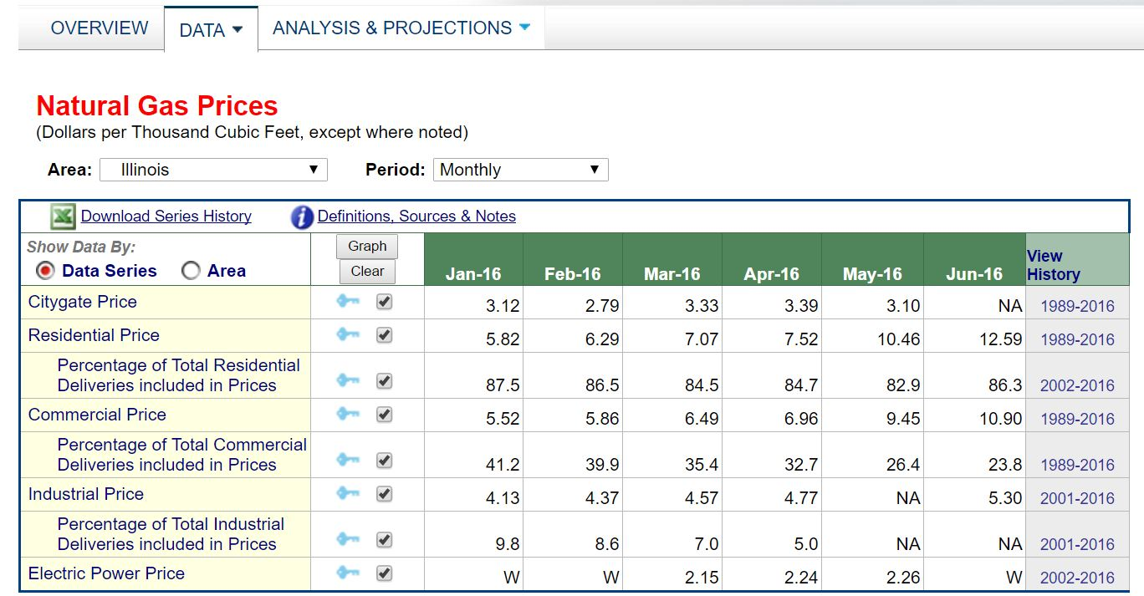

* Temperature measures at the airports in the 3 largest cities: Chicago, Springfield, and Rockford.
* Source: **Weather Underground:** http://www.wunderground.com/history/

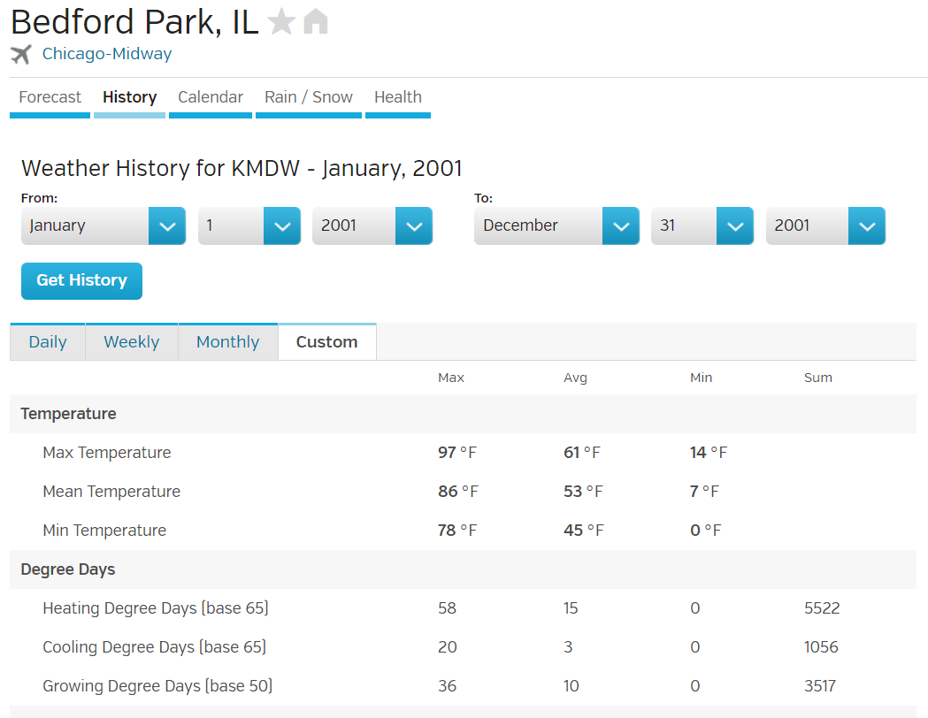

* The heating degree day and cooling degree day data in 3 largest cities: Chicago, Springfield, and Rockford.
* Source: **Weather Data Depot**: <http://www.weatherdatadepot.com/>

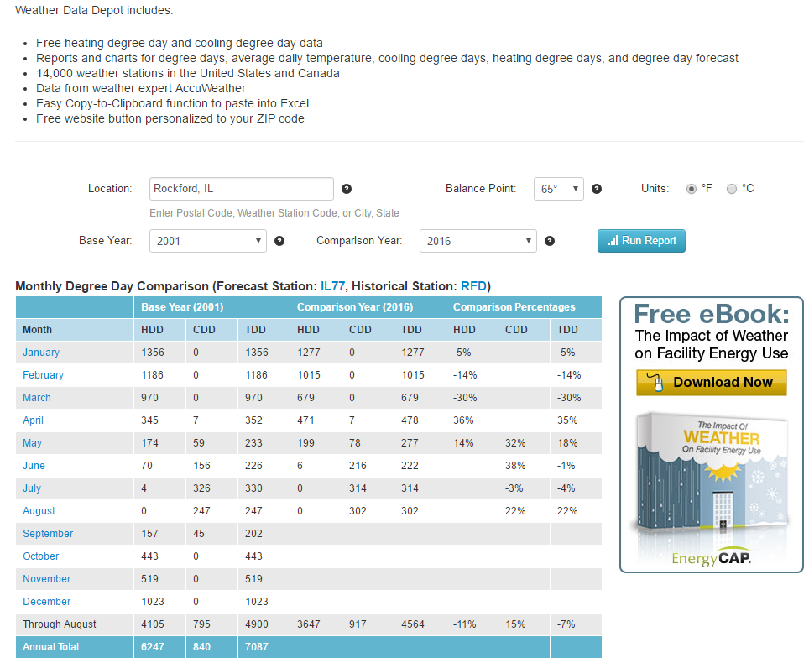

**5. Process Data**

Since some data is only available from 2011 to 2016

Date Trend Month _Total NC Natural Gas _Residential Natural Gas _Commercial Natural Gas _Industrial Natural Gas _Electric Natural Gas Cooling Degree Days Heating Degree Days Mean Maximum Temp Mean MinimumTemp Mean Temp

Date _Total NC Natural Gas _Residential Natural Gas _Commercial Natural Gas _Industrial Natural Gas _Electric Natural Gas Cooling Degree Days Cooling_Degree_Days_POW2 Heating Degree Days Heating_Degree_Days_POW2 Mean Maximum Temp Mean MinimumTemp Mean Temp Trend Month Month_EQ__01 Month_EQ__02 Month_EQ__03 Month_EQ__04 Month_EQ__05 Month_EQ__06 Month_EQ__07 Month_EQ__08 Month_EQ__09 Month_EQ__10 Month_EQ__11 Month_EQ__12

2) Identify all variables to be used in your analysis (Ys and Xs). Identify whether the Xs are numerical or categorical. If study of association without predictability, identify whether Ys are numerical or categorical.

What are heating degree days and cooling degree days?

Heating degree days are indicators of household energy consumption for space heating. It was found that for an average outdoor temperature of 65 degrees Fahrenheit, most buildings require heat to maintain a 70 degree temperature inside. Similarly, for an average outdoor temperature of 65 degrees or more, most buildings require air-conditioning to maintain a 70 degree temperature inside.

How heating and cooling degree days are computed?

Take the high and low temperature for the day, and average them. If this number is greater than 65 F, then we have (Average temperature - 65) cooling degree days. If the average temperature is less than 65 degrees, then we have (65 - Average temperature) heating degree days. Running totals are kept for these units over a time period of a year so fuel distributors and power companies can assess average demands.

3) State actual file names, source (link), and total number of rows in the raw/final dataset. This can be in a "source data" section/table. Also, state time period of the dataset e.g., # of years.

4) State all SAS procedures that you are planning to use for the analysis. If using R, state all libraries to be used.

5) Submit any analysis performed thus far, unzipped, so that it can be viewed via Blackboard previews.

Winter weather strongly influences residential and commercial demand

During cold months, residential and commercial end users consume natural gas for heating, which places upward pressure on prices as demand increases. If unexpected or severe weather occurs, the effect on prices intensifies because supply is often unable to react quickly to short-term increases in demand. The effects of weather on natural gas prices may be exacerbated if the natural gas transportation system is already operating at full capacity. Under these conditions, prices tend to increase, which reduces overall demand for natural gas. Natural gas supplies that were placed in storage during periods of lesser demand may be used to cushion the impact of high demand during inclement weather.

Hot summer weather can increase power plant demand for natural gas

Temperatures can also have an effect on prices during the cooling season. About 33% of U.S. electricity was generated with natural gas in 2015. Warmer than normal temperatures can increase the demand for air conditioning, which increases the power sector's demand for natural gas and can lead to increased prices.

Work Cited:

[1] Energy Information Administration, Monthly Energy Review, March 2016, http://www.eia.gov/totalenergy/data/monthly/pdf/sec1_7.pdf .

[2] Energy Information Administration, Monthly Energy Review, March 2016, http://www.eia.gov/totalenergy/data/monthly/pdf/sec7_5.pdf .